Expt. no: 4 Date:

Introduction to Circuit Simulation using Kicad 8

Objective:
- To perform and practice circuit simulation using following circuits:
  - Half Wave Rectifier
  - Center-tapped Full Wave Rectifier with Capacitive Filter
  - 5V Regulated Power Supply using IC LM7805
- To observe and verify the waveforms obtained with the theoretical waveforms
- To learn how to assign a simulation model to a component using IC LM7805
Equipment:
Software: KiCAD 8
Hardware: Computer/ Laptop with external mouse

Theory:
Simulator
KiCad provides an embedded electrical circuit simulator using ngspice as the simulation engine. ngspice is a SPICE simulator derived from the original widely used Berkeley SPICE program.

When working with the simulator, the Simulation_SPICE symbol library, installed with KiCad by default, is useful. It contains common elements used for simulation such as voltage and current sources, DC and AC signal sources, a ground reference, ideal passive circuit elements such as resistors, inductors and capacitors, and numerous other generic semiconductor device models. Semiconductor manufacturers often freely supply models of commercially-available semiconductors, integrated circuits and other devices as more complex SPICE models to help users simulate and develop circuits using their parts.

While KiCad does not include any commercial SPICE models in its distribution, users are free to use any models they may have, or have used with other circuit simulators, in KiCad’s simulator.

Assigning Models
Users need to assign simulation models to symbols before they can simulate their circuit.
Each symbol can have only one model assigned, even if the symbol consists of multiple units. For symbols with multiple units, you should assign the model to the first unit. SPICE model information is stored as text in symbol fields. Therefore users may define it in either the symbol editor or the schematic editor.

Exclude from simulation
A symbol can be excluded from simulation entirely by checking the exclude from simulation checkbox in the Symbol Properties dialog.

SPICE Directives
It is possible to add SPICE directives by placing them in text fields on a schematic sheet. This approach is convenient for defining the default simulation type. Directives start with a dot e.g.,
.tran 1u 40m
If a simulation command is included in schematic text, the simulator will use it as the simulation command when the user opens the simulator. However, it can be overriden in the Simulation Command dialog.

Running Simulations
Circuits for simulation are drawn in the Schematic Editor, but simulations are run in the Simulator window. To run a simulation, open the SPICE simulator dialog by clicking Inspect → Simulator in the schematics editor window or using the button in the top toolbar.

The dialog is divided into the following sections:
- The top of the window has a toolbar with buttons for commonly used actions.
- The main part of the window graphically shows the simulation results. Signals need to be selected from the list of available signals or probed before they are displayed in the plot.
- Below the plot panel, the output console shows logs from the ngspice simulation engine.
- The right side of the window displays a list of signals, a list of active cursors, measurements, and a tuning tool for adjusting component values based on simulation results.

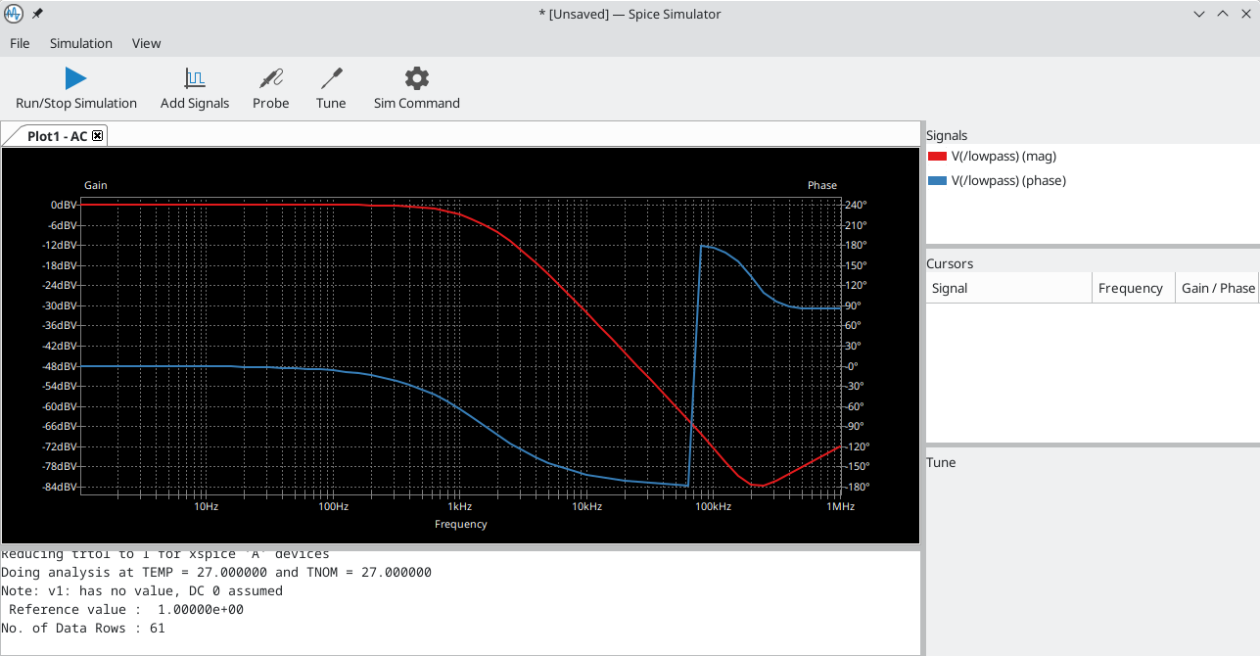
Fig. 4.1 A Sample waveform in the Kicad 8 Spice Simulator

Procedure to perform the experiment:
- Create your PCB Design:
  - Open KiCad and create a new project.
  - Use the Schematic Editor to design your circuit schematic by adding components and making connections as needed.
  - Perform the Electrical Rules Check (ERC) and make sure there are no errors in the circuit. Add power flags wherever necessary.
- Set Up Simulation:
  - Ensure that the SPICE models have been assigned for the components you are using.
  - For the components that do not have a simulation model, you can often find these on the manufacturer’s website or within a library file (.lib). In this experiment, IC a library file containing the LM7805 model has been provided to you externally.
To assign a simulation model to a symbol:
    - Open the Symbol Properties dialog and click the Simulation Model…​ button, which opens the Simulation Model Editor dialog.
    - Browse to your .lib file location and open it.
    - Select your model of choice from the dropdown list that shows all available simulation models provided in the .lib file.
  - Add Simulation Components: Include voltage sources and other test components that help simulate your circuit.
- Configure the simulation parameters (transient, AC, DC, etc.) in the simulation setup dialog or by adding the text field in the schematic.
- Perform a Simulation:
  - Open the simulator.
  - Select the signals whose waveform you wish to view from among the list that gets created from the circuit.
  - Click on the Run button.
- View results: Once the simulation finishes running, you can view the results in the waveform viewer. Analyze voltages, currents, and other parameters to ensure your design behaves as expected.
- Iterate: Modify your circuit based on the simulation results and rerun the simulation to validate changes.

Implementation:
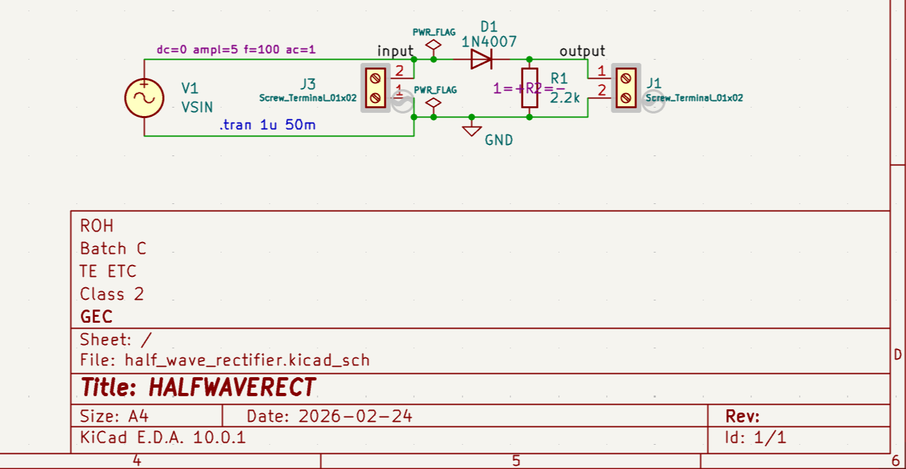
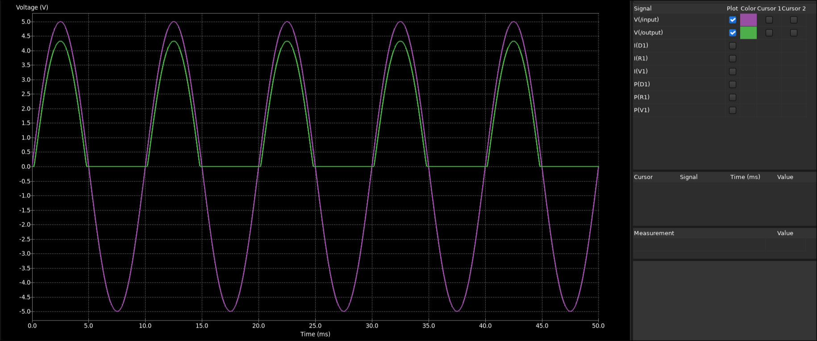
Fig. 4.2 Half Wave Rectifier Circuit Schematic and the waveform obtained after simulation

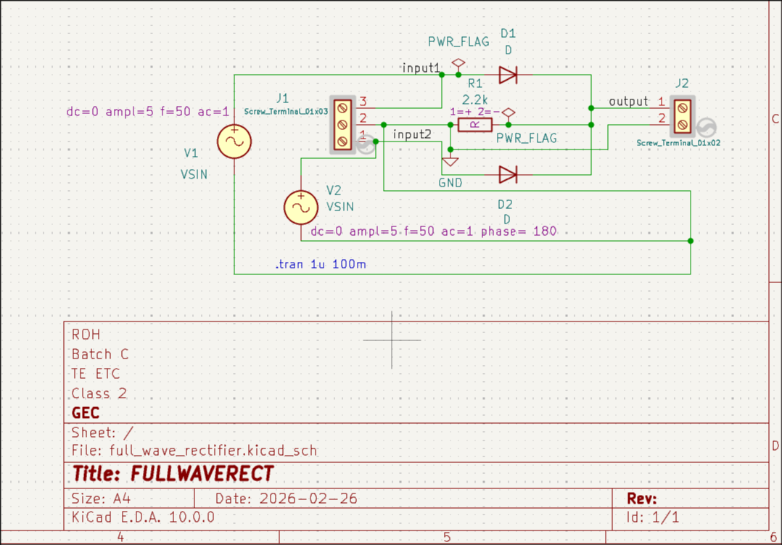
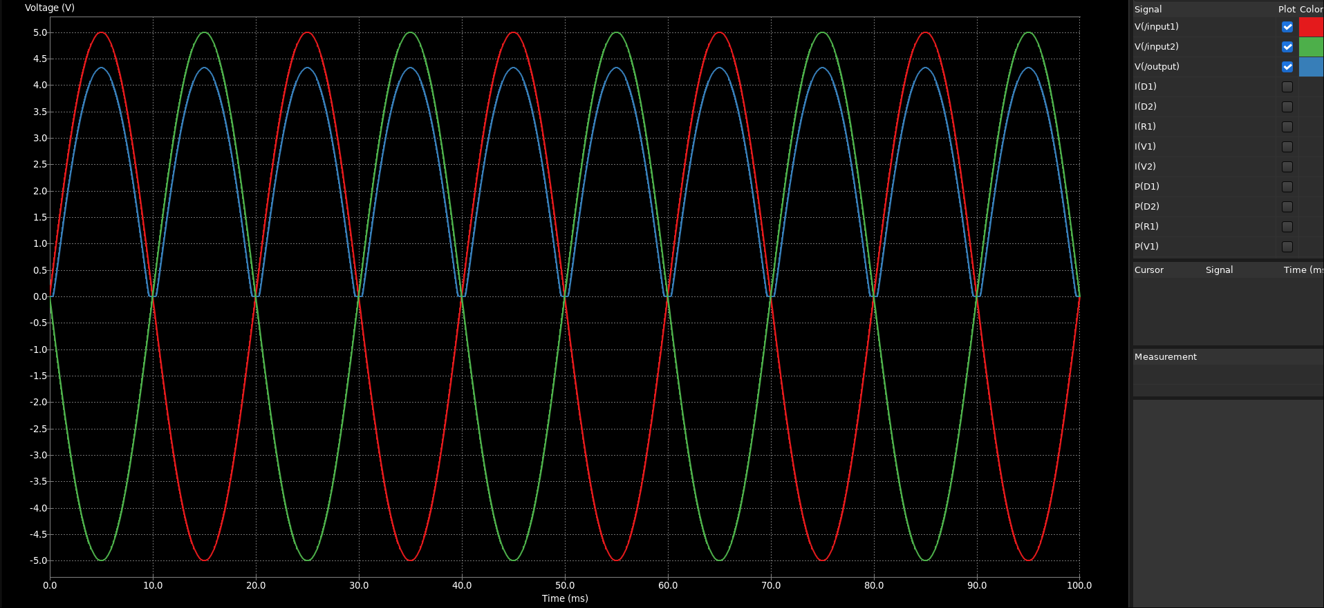
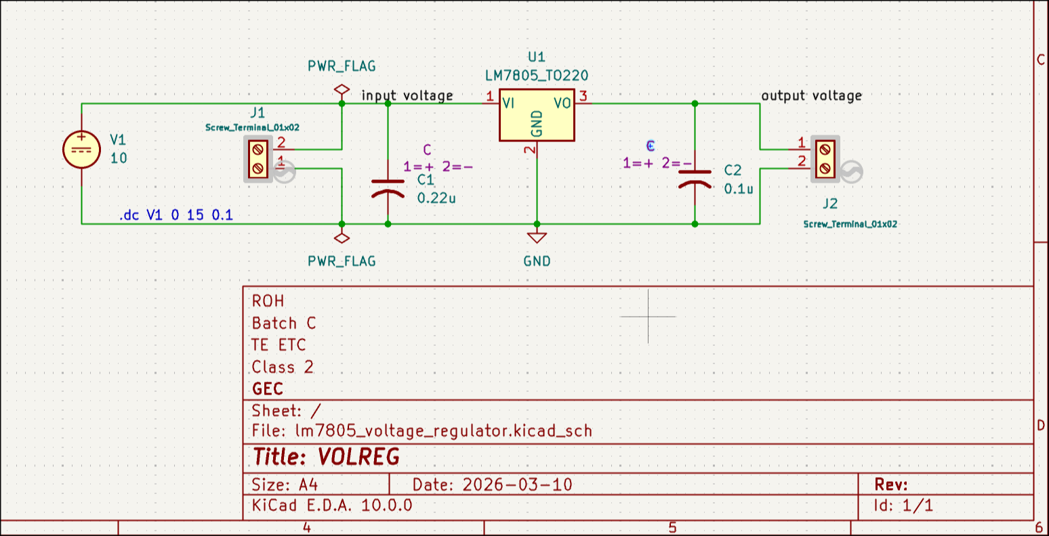
Fig. 4.3 Center-Tapped Full Wave Rectifier Circuit Schematic and the waveform obtained after simulation
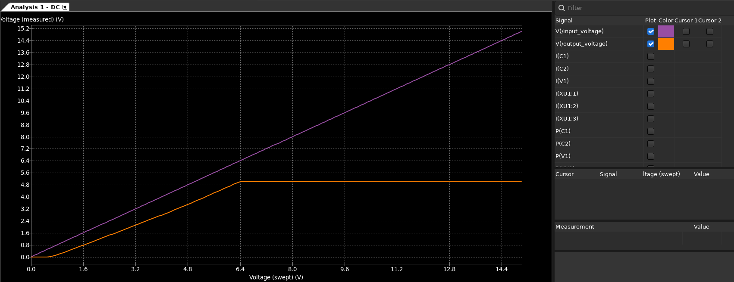
Fig. 4.4 5 Volts regulated Power Supply Schematic and the waveform obtained after simulation

Results:

1) For half wave rectifier:
- Input voltage = 5V (peak)
- Theoretical peak output = 5V-0.7V(due to diode drop) = 4.3V, one pulse per cycle
- Peak output obtained from waveform = 4.32V, one pulse per cycle

2) For full wave rectifier:
- Input voltage = 5V (peak)
- Theoretical peak output= 5V -0.7V(due to diode drop) = 4.3V, one pulse per half-cycle
- Peak output obtained from waveform = 4.32V, one pulse per half-cycle

3) For LM7805 voltage regulator:
- Input voltage = from 0 to 15V
- V_{dropout}=V_{in(min)}-V_{out}=7V-5V=2V(7V is the minimum voltage required for LM7805)
- Theoretical output voltage ≈ 5V ; V_{in} ≥ 7V
< 5V ; V_{in} < 7V, follows input behaviour
- Output obtained from waveform = 5.014V ; V_{in} ≥ 7V
< 5V ; V_{in} < 7V, follows input behaviour

Challenges: The main challenge in this experiment was understanding the simulation constraints and the meaning of the commands. I initially struggled until I discovered that the frequency significantly impacts the selection of the start and stop times for the simulation. Additionally, I found step time to be another unfamiliar concept. It determines how many samples are taken to plot the waveform, which is crucial for achieving an accurate representation of the signal.

Conclusion:
- Circuit simulation was performed and practices using following circuits:
  - Half Wave Rectifier
  - Center-tapped Full Wave Rectifier with Capacitive Filter
  - 5V Regulated Power Supply using IC LM7805
- The waveforms obtained were observed and verified with the theoretical waveforms.
- An externally obtained simulation model was assigned to the IC LM7805.

